**One task is completed at a time other task needs to completed**

**Step1: Create a BPD, which is having maker, checker, parallel gateway & script.**

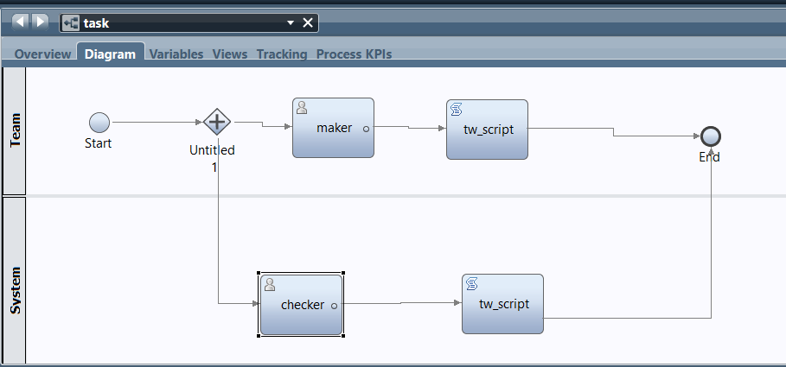

**Step2: In variable section, declare private variables Task ID, Current User and instance ID.**

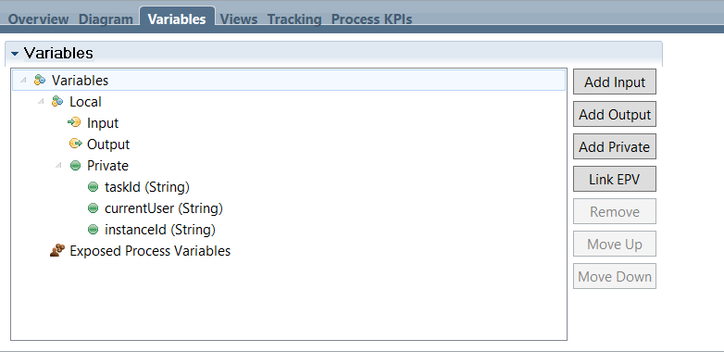

**Step3: we will write post assignment for both to obtain the task step owner.**

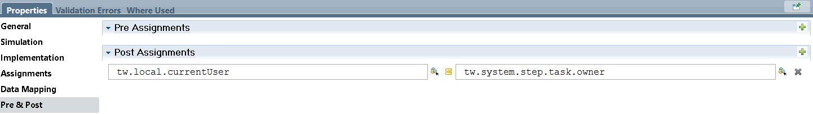

**Step4: we will write Tw search script to obtain task ID, process name, task subject, task status, process instance ID, In that script only we will re assign the task to that current user, After that if we run the task it will end the both task at a time with same owner.**

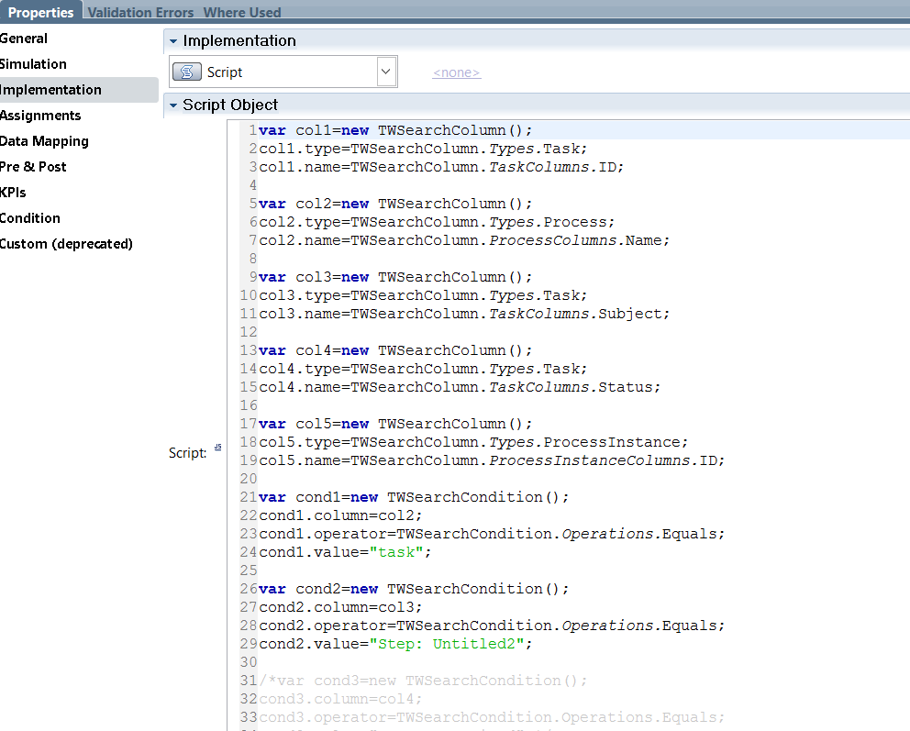

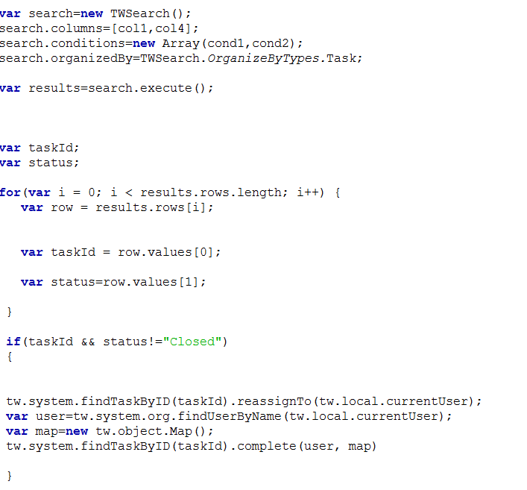

**Step5: if we run the task it will complete with the same owner.**

